Press release

**Checkmate for dull men’s staples**

**BLACKSOCKS men’s underwear in a stylish chessboard pattern**

Swiss online pioneer BLACKSOCKS’ sleek new collection of boxers is flying the flag for men’s underwear.

These checked boxer shorts made of the finest Pima cotton are the perfect style gambit, as well as offering a perfect, fantastically comfortable fit. These boxer shorts with a classic chessboard design are launching in August. First come, first served! The boxer shorts are available in the sizes S to XXL. Quick and simple with easy online ordering from [BLACKSOCKS](https://www.blacksocks.com/eu/de/unterhosenshop).

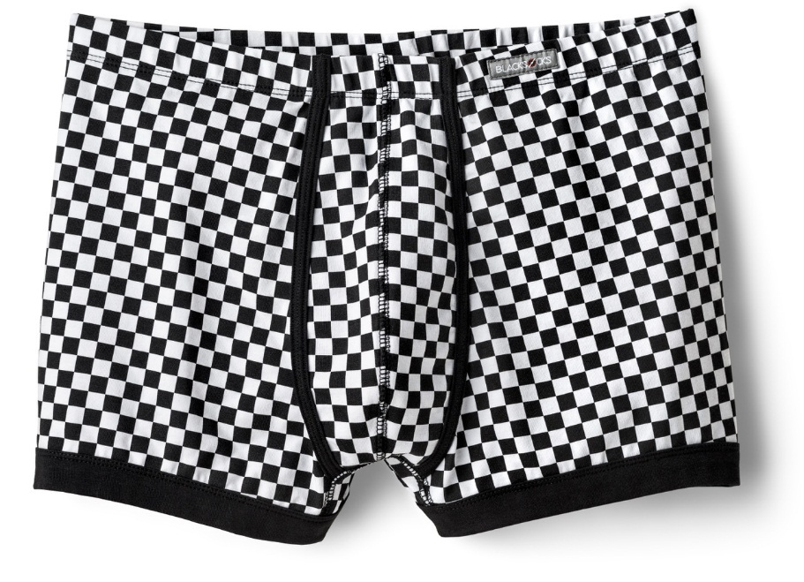

**ABOUT BLACKSOCKS**

Completely free of any more sock sorrows – the concept with which Samy Liechti, founder of **BLACKSOCKS** and inventor of the sockscription business model, revolutionised the e-commerce business 18 years ago. Today, this business model has been established worldwide and **BLACKSOCKS** now supplies more than 60,000 customers in 129 countries across the world with classic socks such as calf socks or knee socks, as well as men’s basics such as shirts, T-shirts and underwear. Subscribers receive the designs of their choice delivered free of charge to their door - convenient and modern. www.blacksocks.com